**Create a ASP.NET with .NET CLI and Visual Studio Code**

<https://docs.microsoft.com/en-us/learn/modules/build-web-api-aspnet-core/>

1. Create a project

dotnet new myApp –no-https

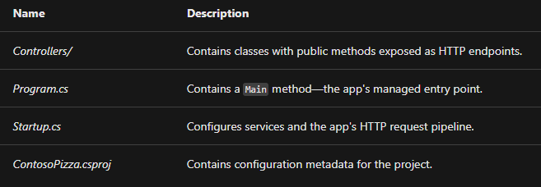

1. Build and Run

dotnet build

dotnet run



Create Follows:

1.Controller for CRUD http response

2. Model for entity class

3. Data Service for Get/Add/Delete/Update Method

Test APIs:

dotnet tool install -g Microsoft.dotnet-httprepl

httprepl <http://localhost:5000>

connect <http://localhost:5000>

post -c "{"id": 3, "name":"Hawaiian", "isGlutenFree":false}"

put 3 -c "{"id": 3, "name":"Hawaiian", "isGlutenFree":true}"

delete 3

**Dockerize an ASP.NET app**

https://docs.docker.com/samples/dotnetcore/

<https://code.visualstudio.com/docs/containers/quickstart-aspnet-core>

buildAndRunImage.sh

<http://localhost:8080/Pizza>

**Debugging**

Install .NET Extension Pack

Install [C# for Visual Studio Code](https://marketplace.visualstudio.com/items?itemName=ms-dotnettools.csharp) extension

EXPOSE 5000 OR 5001

.vscode/lauch.json

Adding below under configurations

{

            "name": "Docker .NET Core Launch",

            "type": "docker",

            "request": "attach",

            "preLaunchTask": "docker-run: debug",

            "netCore":{

                "appProject":"${workspaceFolder}/ContosoPizza.csproj"

            }

        },

